



Implement scheduling problem
LAB MANUAL

Disclaimer: The content is curated from online/offline resources and used for educational purpose only
Implement a scheduling problem (e.g., assigning workers to tasks) using bitmask DP.

Objective:
Implement a scheduling solution using bitmask dynamic programming (DP) to assign workers to tasks efficiently.
Problem Statement:
Given a matrix cost[i][j] where cost[i][j] represents the cost of assigning worker `i` to task `j`, implement a bitmask DP solution to find the minimum cost to assign all tasks to workers such that each worker is assigned exactly one task and each task is assigned to one worker.

Equipment Required:
- Python installed with Jupyter Notebook

Prerequisites:
- Basic understanding of dynamic programming
- Familiarity with bit manipulation
- Knowledge of recursive functions and memoization

Procedure:
Step 1: Define the Bitmask DP Function
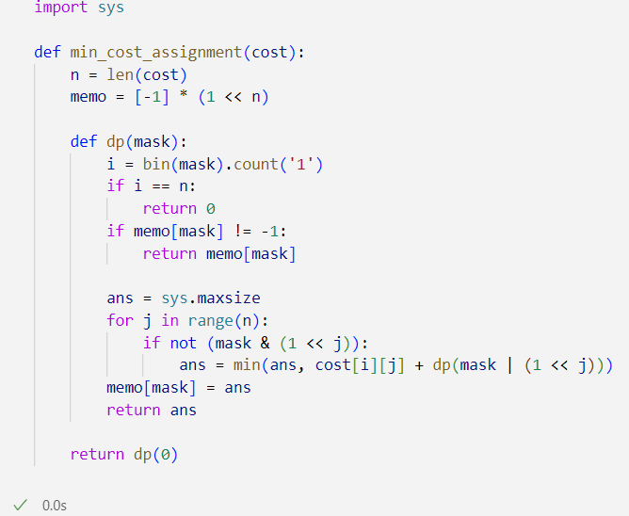

Step 2: Define a Sample Cost Matrix and Run the Function

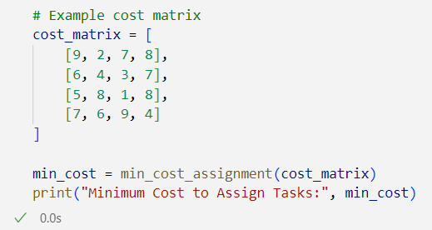

Output:

Conclusion
This lab implemented a scheduling problem using bitmask dynamic programming, which is efficient for small-sized assignment problems. The approach helps understand the combination of DP and bit manipulation techniques used in complex problem-solving scenarios such as job assignment, load balancing, and resource allocation.

